SEC Yield Customer API Code Challenge

Revision History
Author | Revision Number | Date
TCSDEVELOPER | 1.0 | 2016-08-20

1. Organization of Submission 3
2. Prerequisites 3
3. Configuration 3
4. Application Setup 4
5. Verification 5
Customer API 5
SEC Yield API 7
Tests 10
6. Resource Contact List 11

Organization of Submission

customerapi
The customer REST API module.

docs
Contains deployment guides and Postman collection files.

seccommons
The common code module.

secyieldapi
The SEC Yield REST API module.

test_data
Contains sql scripts that populate the db with test data.

README.md
The project documentation in Markdown format.

Prerequisites

Java 8 http://www.oracle.com/technetwork/java/javase/downloads/jdk8-downloads-2133151.html
Tomcat 8 https://tomcat.apache.org/download-80.cgi
Maven https://maven.apache.org/download.cgi
MySQL https://www.mysql.com/

Configuration

secyieldapi module

These are the most important variables that can be configured for secyieldapi module:

Name | Location | Description | Example value
secyieldserviceimpl.maxNumberOfSecurityData | secyieldapi/src/main/resources/constants.properties | The maximum number of security data to be returned by the API | 100

customerapi module

These are the most important variables that can be configured for customerapi module:

Name | Location | Description | Example value
operationScale | customerapi/src/main/resources/constants.properties | The operation scale used by calculator engines | 7
roundingMode | customerapi/src/main/resources/constants.properties | The rounding mode  used by calculator engines | 4
mysql.url | customerapi/src/main/resources/db.properties | The MySQL url | jdbc:mysql://localhost:3306/secyield
mysql.username | customerapi/src/main/resources/db.properties | The MySQL username | root
mysql.password | customerapi/src/main/resources/db.properties | The MySQL password | passwd

For tests, make sure you provide the correct db credentials in customerapi/src/main/resources/applicationContext-test.xml:

<!-- dataSource configuration -->

<bean id="dataSource"

class="org.springframework.jdbc.datasource.DriverManagerDataSource">

<property name="driverClassName" value="com.mysql.jdbc.Driver" />

<property name="url" value="jdbc:mysql://localhost:3306/test-secyield" />

<property name="username" value="root" />

<property name="password" value="root" />

</bean>

Application Setup

Follow these steps to get the APIs running:

Connect to MySQL:

$ mysql -u root -p

Create “secyield” and “test-secyield” dbs if they doesn't exist (“test-secyield” db is used for integration tests):

mysql> CREATE SCHEMA `secyield`;
mysql> CREATE SCHEMA `test-secyield`;

In seccommons folder, run the following command:

$ mvn clean install

In customerapi folder, run the following commands:

$ mvn clean install
$ mvn spring-boot:run

In the mysql command line, switch to “secyield” db:

mysql> use secyield;

Populate the db with test data:

mysql> source <path_to_test_data>;

where <path_to_test_data> is the absolute path to test_data/test_data.sql.

In secyieldapi folder, run the following commands:

$ mvn clean install
$ mvn spring-boot:run

Verification

All input dates for the 2 REST APIs must follow this format: yyyy-dd-MM (see com.csa.apex.secyield.utility.Constants.API_DATE_FORMAT).

Open docs/sec_yield_api_postman_collection.json and docs/customer_api_postman_collection.json in Postman application

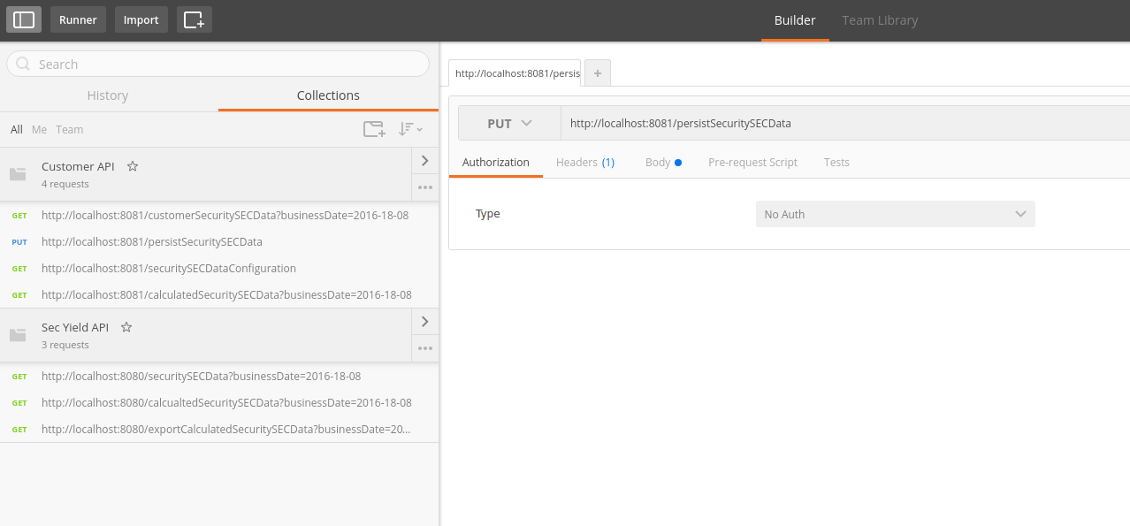

FYI, the test data contains data between 2016-15-08 and 2016-19-08.

Customer API

GET /customerSecuritySECData
Gets the customer SEC security data (without yield and income calculated).

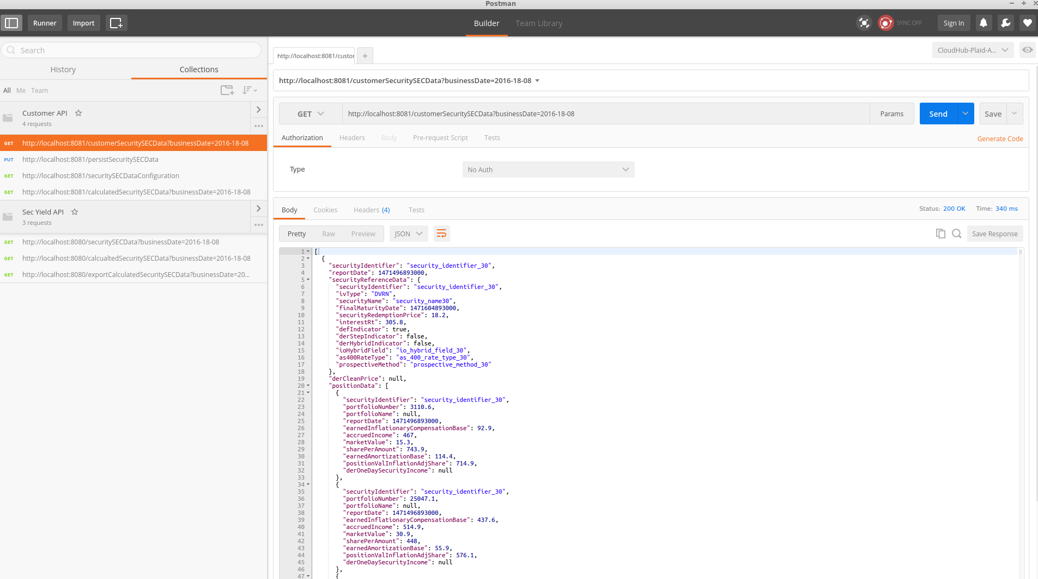
PUT /persistSecuritySECData
Persists the calculated SEC security data.

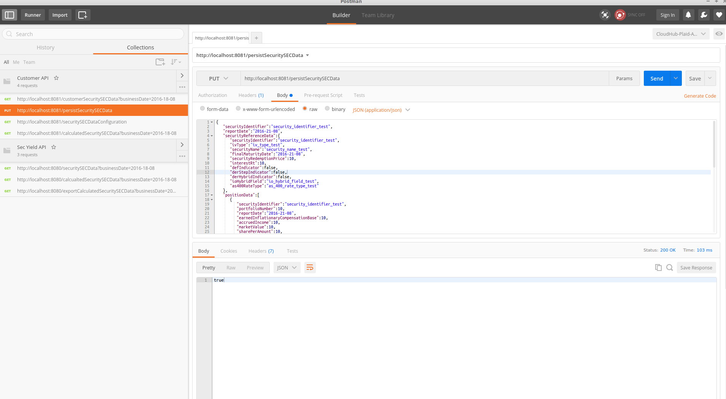

GET /securitySECDataConfiguration
Gets SEC security config for the calculations in engines.

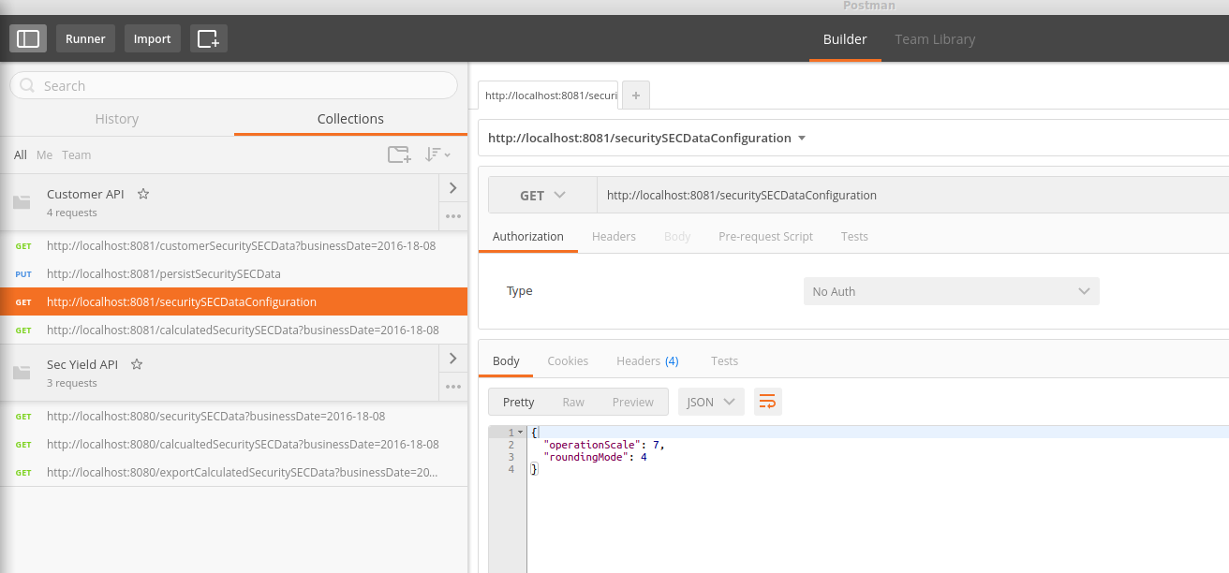

GET /calculatedSecuritySECData
Gets the calculated SEC security data.

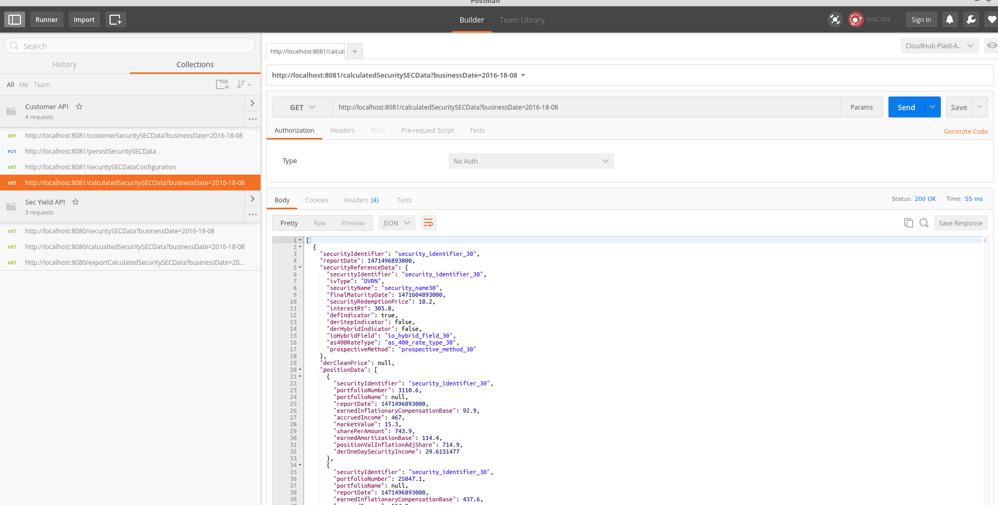

Note that ifdata was not calculated previously (by calling the SEC Yield API GET /securitySECData), an empty array will be returned by this request. In my test I already had some calculated data before.

SEC Yield API

Note the number of retrieved results. It must not exceed the configured “secyieldserviceimpl.maxNumberOfSecurityData”

GET /securitySECData
Gets SEC Security data with the calculated data for the business date. The securities are also persisted using customer REST API.

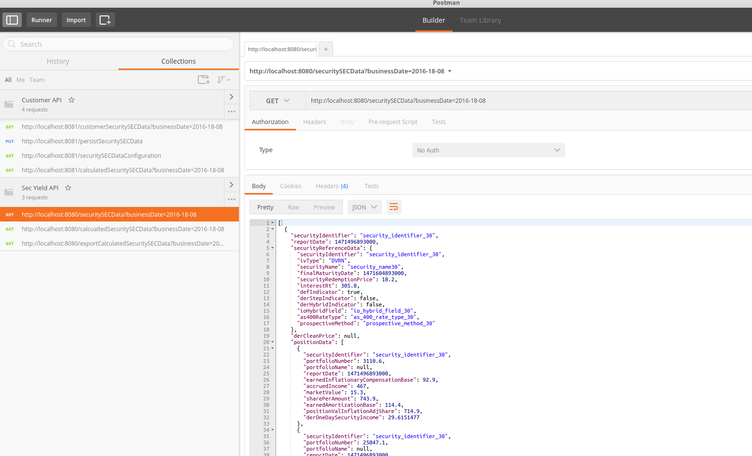

GET /calcualtedSecuritySECData
Gets already calculated SEC Security data for the given date.

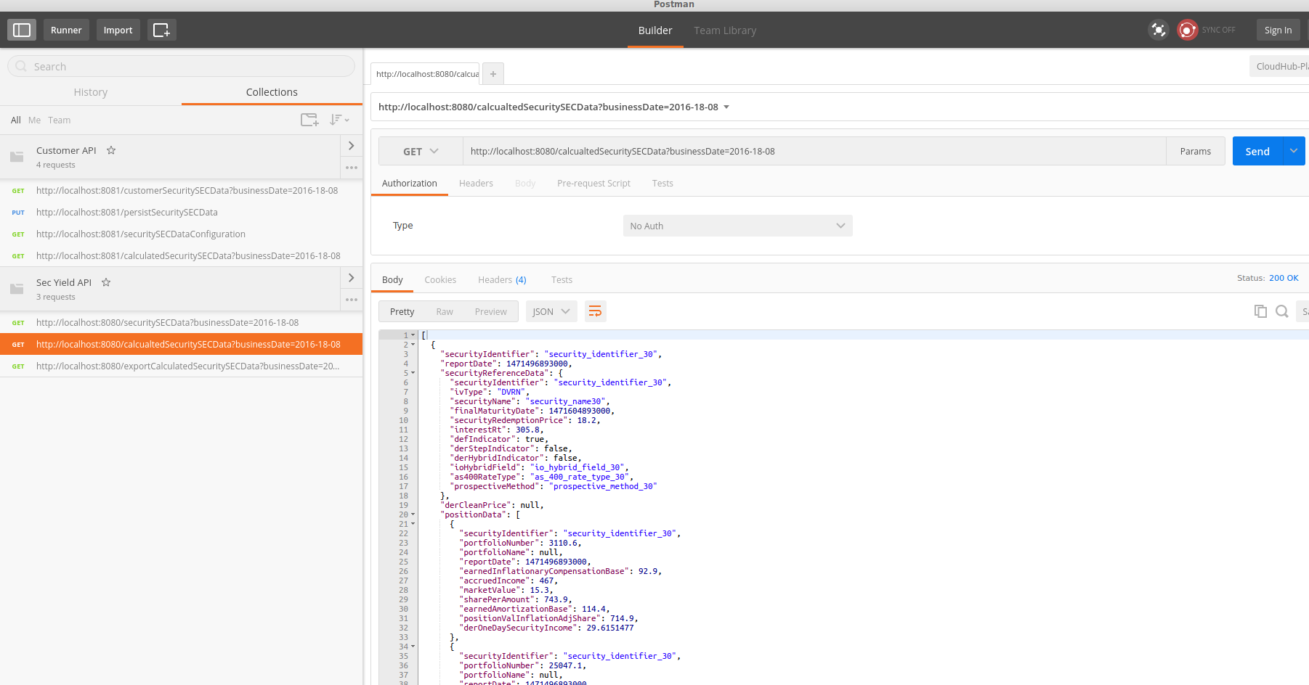

GET /exportCalculatedSecuritySECData
Exports calculated SEC Security data for the given date.

For downloading, click the arrow near the Send button and then click “Send and Download”.

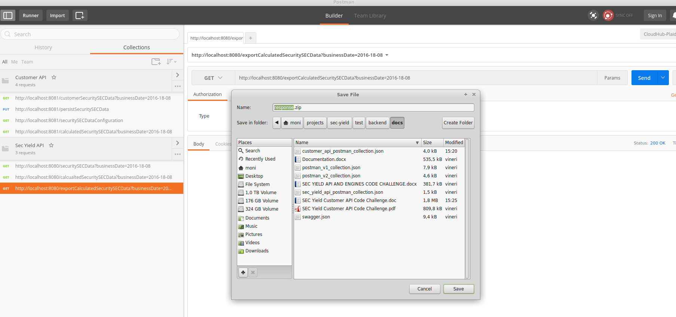

In order to get the correct file name of the export, please test this url in a browser.

Export file sample:
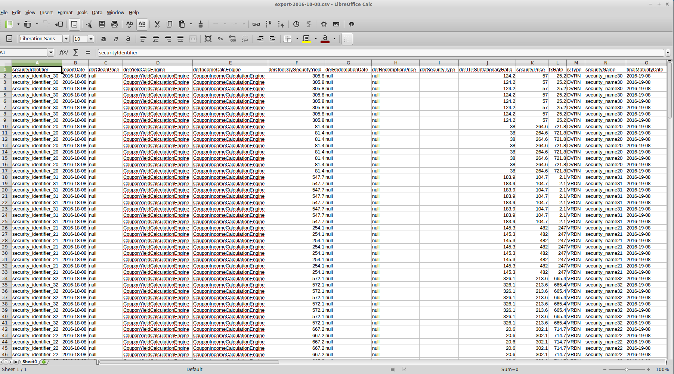

Tests

In seccommons folder, run the following command:

$ mvn test

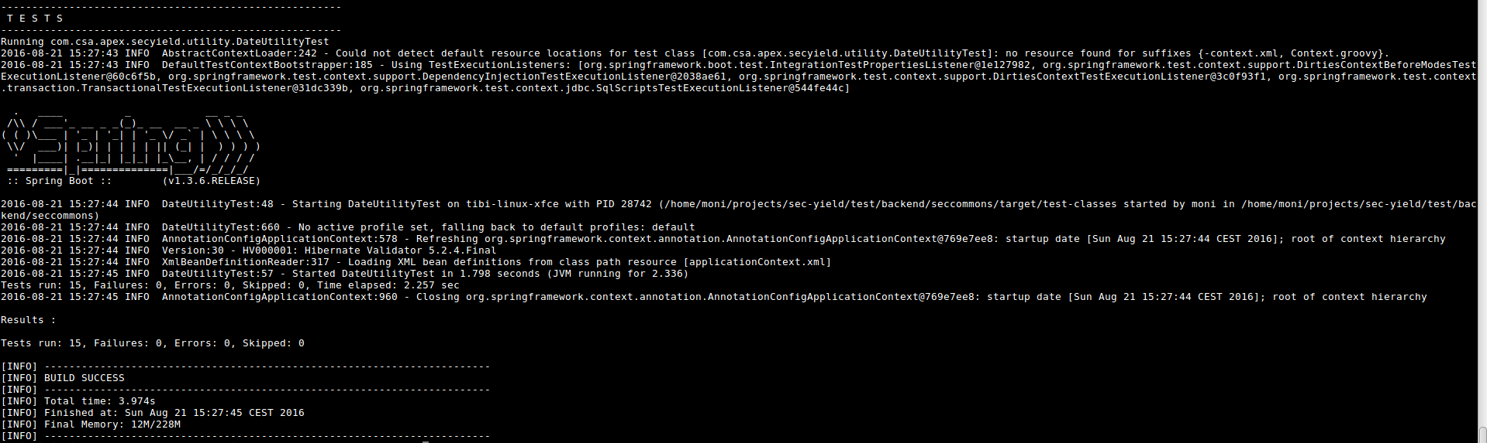

In customerapi folder, run the following command:

$ mvn test

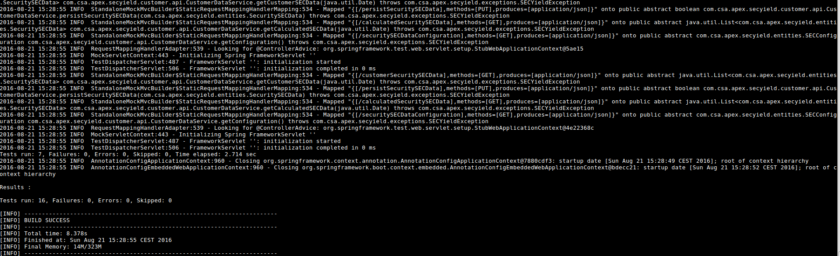
In secyieldapi folder, run the following command (the Customer API has to be running when executing SEC Yield API tests because the “configuration”
field in com.csa.apex.secyield.api.services.impl.SECYieldServiceImpl is initialized by making a REST API call to Customer API):

$ mvn test

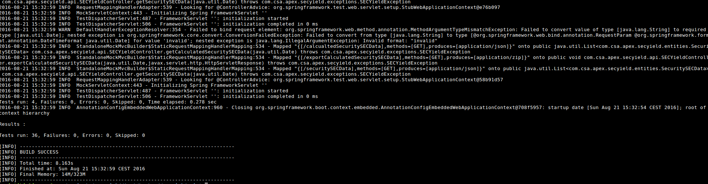

Resource Contact List

Name | Resource Email
TCSASSEMBLER

